ASSIGNMENT 8
Subqueries

Follow the same formatting guidelines as the previous homework assignment.

YOU must use subqueries. Do not put any codes in your SQL statements. When pasting your results, just provide the first five rows of output if your result set exceeds five rows
1 | Copy and paste the contents of student.txt into your SQLPlus session. Rename the tables such that they are all prefixed with the first five letters of your lastname such as sabze_student. Make sure that the tables (student, class and student_class) are all renamed properly before you continue. You don’t need to paste anything from SQLPlus for this question.
1 |  | Using a single SQL statement display fname,lname of all the students who are taking Database Programming regardless of case.
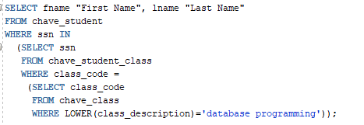

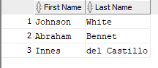
2 |  | Using a single SQL statement display all the rows from the student_class table where class description is not null
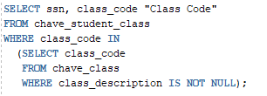

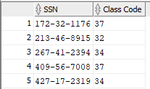
NOTE: Only the first 5 rows of the output are shown

3 |  | Using a single SQL statement display fname, lname of all the students whose first name is anything except John, Jack or Bob. and are taking the operating systems class and their phone number is null
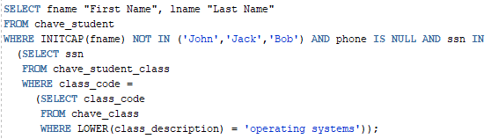


4 |  | Using a single SQL statement display ssn, fname, lname, age/2 of all the students whose first name begins with the letter J and age is greater than 25 and are taking any class that contains ‘Intro’ in its description (Have to convert the dob into a number). Order the results by age/2 in descending order. Use an alias for the order by clause
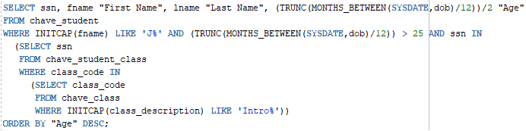

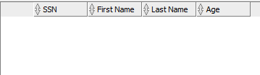
5 |  | Using a single SQL statement display fname, lname from the student table where last name contains the letters ‘nn’ (e.g. Benny, Bonny, Sonny) and is enrolled in any class that contains the letter ‘h’ in its description regardless of case. Order the results by lname. When using order by use the position and not the name of the column
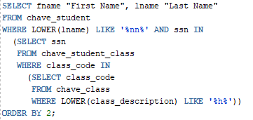


6 |  | Using a single SQL statement, delete all the rows from the class table for all classes that are associated with students who live in Sacramento and earn less than 15000 (NOTE: you are deleting from the class table)
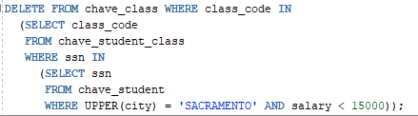

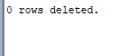
7 |  | Using a single SQL statement use a combination of create and select to create a new table called class2 that contains the list of all the classes that are taken by students who are older than 30 years old
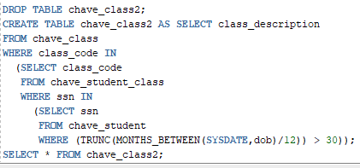

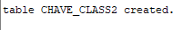
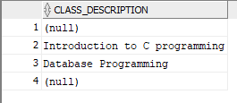
8 |  | Update the salary to 75000 for all students who are enrolled in ‘Database programming’ regardless of case and live in CA
 |  | 